**Tinker cad case Study Building Humidity sensor with Arduino**

**Setup and login to tinker cad**

**Click on create circuit:**

**Add Arduino uno r3**

**Add bread board.**

**Add potentiometer to the circuit.**

**Add temperature sensor.**

**Connect A0 to Vout of Temperature sensor.**

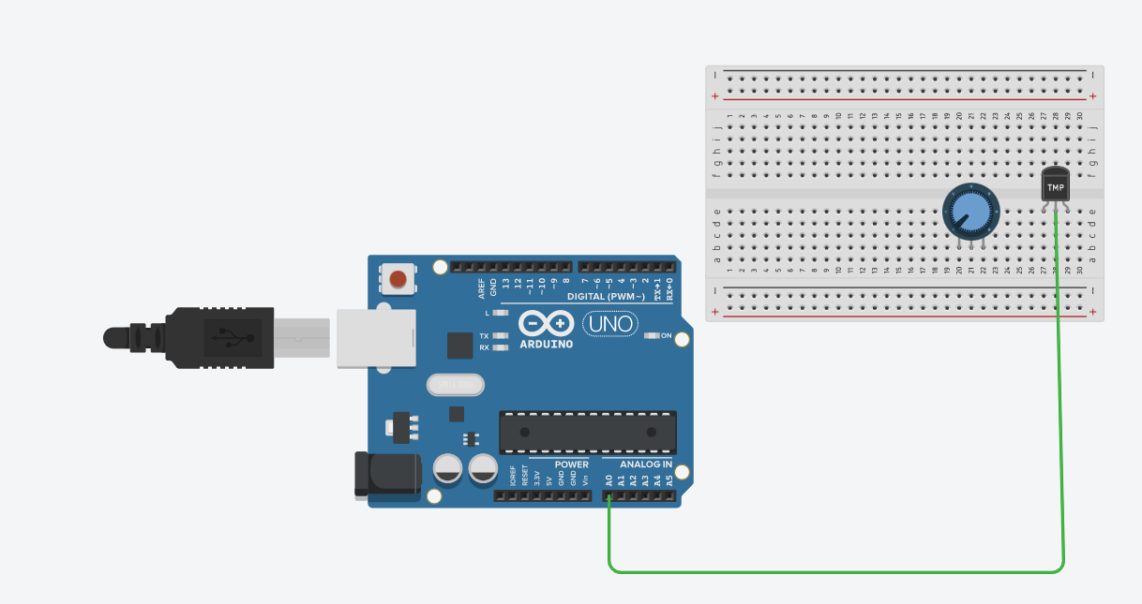

**Connect A1 to wiper of potentiometer.**

**Connect ground to gnd of temperature sensor and terminal 1 of potentiometer**

**Power connection of 5v**

**To complete the circuit**

**Out puts:**

